DMET 909 — GAME DESIGN
German University in Cairo
Dear Anna

Assignment 2 — Game World & Game Mechanics

Mohamed Ashraf
17 October 2026

Contents

Foreword — A Note on the Design 4
Part 1 — The Game World
1.0 Overview 6
1.1 Locations 6
1.2 Non-Player Characters 8
1.3 Scale 10
1.4 Temporal Dimension 11
1.5 Spatial Boundaries 13
1.6 Object Catalogue 14
1.7 The ColorKeep Motif 18
1.8 A Walkthrough of the Experience 19
Part 2 — Game Mechanics
2.0 Overview 22
2.1 Player Actions 22
2.2 Movement Mechanics 22
2.3 Interaction Mechanics 23
2.4 Navigation Across Terrains 23
2.5 Weapon Usage 24
2.6 Consumables & Resource Management 24
2.7 Mechanics Catalogue 24
2.8 Narrative & State Systems 27
2.9 Design Rationale 28
2.10 Design Precedents 29
2.11 Accessibility & UX Considerations 30
Part 3 — Prototype Implementation
3.0 Overview & Toolchain 32
3.1 Player Actions 32
3.2 Camera 33
3.3 Lighting 35
3.4 Input & Interaction Architecture 36
3.5 Picture-Frame Geometry (FramePictureCore) 37
3.6 Scene & Project Organization 38
Part 4 — Compliance Overview
4.0 Requirement Coverage 41
Appendix A — Script Registry 42
Appendix B — Future Work 43
Credits & Tools 44

Foreword — A Note on the Design

“Dear Anna” is a first-person narrative prototype set between two addresses Stanislav Alexandrovich never quite reconciles: the room he is sitting in, and the page he is writing on. The premise is simple on its surface — a man, back in St. Petersburg after several years away, spends a quiet night reading old letters, handling old objects, and eventually falling asleep into a dream built from the things he has not been able to say out loud. The design problem underneath it is less simple: how do you make a game about guilt and memory without a single enemy, a single health bar, or a single other person physically in the room?
The answer this prototype commits to is correspondence. Every other character in Stanislav's life — Anna most of all — exists in this game exactly the way they exist in his actual life at this point in the story: as handwriting, as a photograph, as an object kept rather than used. The player does not talk to these people. The player reads them, the same way Stanislav does, at the same remove.
That remove is also the project's visual thesis. Across both the waking room and the dream that follows it, the world is rendered in something close to monochrome — a single global desaturation pass that does not care whether the player is awake or dreaming, because for Stanislav the distinction has stopped mattering very much. The one exception, repeated in every room, is a vase of flowers that the renderer deliberately keeps in colour no matter what else fades. It is a small trick technically — a render layer, a feature flag — and it carries most of the project's emotional argument.
This document describes what that argument looks like in practice: the world it is staged in (Part 1), the mechanics that let a player move through it (Part 2), and the state of the Unity prototype as of this submission (Part 3), followed by a compliance overview and two short appendices (Part 4). It follows the brief's own section structure directly, rather than a structure of its own invention, specifically so each requirement can be found exactly where the brief says to look for it.
One thing is worth saying about how this document itself was put together, since it shaped everything that follows: nothing in Parts 1 through 3 is aspirational. Every object, every narration line quoted in full, every script name, and every numeric claim (room dimensions, field-of-view values, mechanic counts, object counts) was checked directly against the live Unity project rather than written from memory of an earlier design pass, specifically so that a reader opening the project after reading this document finds exactly what was described — the prototype as it currently stands, not as it was once planned.

PART 1
The Game World

“The one thing in this room that still has its colour. I don’t know why — only that when everything else went grey, this didn’t.”
— narration attached to FlowersInVase

1.0 Overview

Part 1 covers the world “Dear Anna” takes place in: where it is and what it actually looks and feels like to stand in (1.1), the people in Stanislav's life who the player never meets as characters but comes to know anyway (1.2), how large the space really is in metres (1.3), when the story takes place and how it handles time (1.4), where its edges are and why (1.5), a complete catalogue of every object a player can do something with (1.6), the render technique that gives the whole thing its visual identity (1.7), and a walkthrough of how all of it meets in a single play session (1.8).

1.1 Locations

Two interior spaces make up the whole of “Dear Anna,” and a third is visible but never entered. Figure 1 maps how they connect; this section describes what each one actually looks and feels like to stand in.
Stanislav's room is where the game begins and, structurally, where it also ends — every session opens here, and the dream itself is reached from this one space. It reads as a well-kept but lived-in study-bedroom: papered walls under a brass chandelier, a wood floor worn paler in the paths between the door, the bed, and the writing desk. A cold iron stove sits in one corner; a bookcase lines another; a writing desk sits directly under the room's one window, with an inkwell, a pamphlet, and a vase of flowers arranged on it. Nothing in the room is new — the furniture is the kind that is inherited, not bought — and nothing in it is broken, either: this is a room that has been maintained by someone with very little else to occupy his evenings. Lighting is a single chandelier, switched by hand (3.3), against a desaturation pass (1.7) that leaves everything in the room — the chandelier's brass, the desk's dark wood — close to grey. The one deliberate splash of colour, the flowers on the desk, is where the eye actually lands, which is the entire point of 1.7.
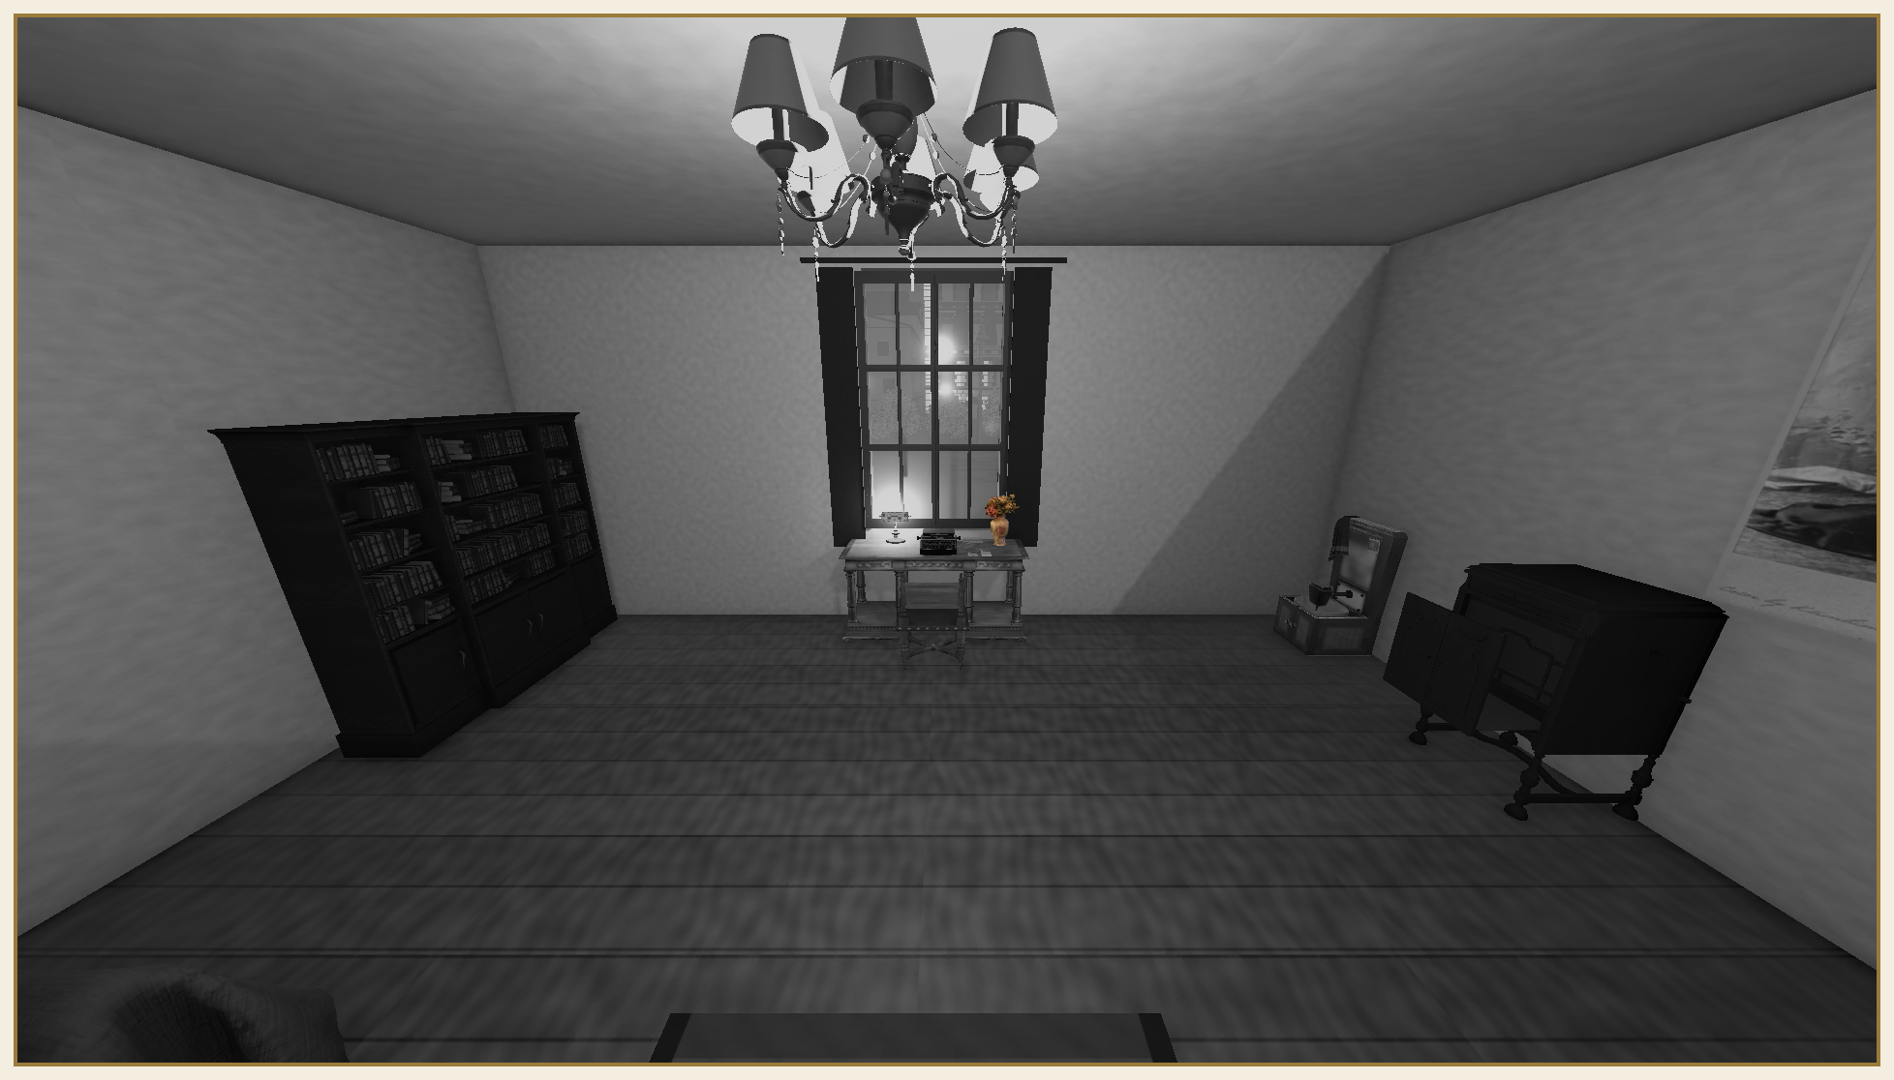
The writing desk, directly under the room's one window — chandelier, bookcase, and the flowers in the one colour the room still has.
Nevsky Prospect is the street outside that window, and it is worth being precise about what that means: it is not a second location, not a place the player's collider can ever occupy, and not modelled past what is visible through the glass. What is visible is deliberately alive — a carriage and a tram loop past on independent fixed cycles (StreetVehicleLoop, Table 3) — specifically so the window reads as a view onto a world that keeps moving, not a painted backdrop. A player can stand at the window for the whole session and never be offered a door to the street, because there isn't one; 1.5 gives the complete account of why.
The dream hall is reached once, each session, through the door at the back of the room, and nothing about the way it looks confuses it for a continuation of the same place. Where the room is modestly sized and evenly lit, the hall is larger (1.3), dimmer, and longer than a single glance can take in — a corridor-like sequence of alcoves rather than one rectangular room, each alcove holding one or two framed memories (Table 2) close enough together to read as a deliberate arrangement rather than clutter. The same desaturation that mutes the waking room is total here too, with the same flower-pot exemption recurring at intervals (1.7) — proof, visually, that this is still Stanislav's own perception at work, not a different art style for a different space. Materials read as older and less cared-for the further back the hall goes: a locked safe and a pair of visibly corrupted picture frames (1.6, 3.5) sit at the hall's furthest, least-visited reach, as if memory itself grows less reliable with distance.
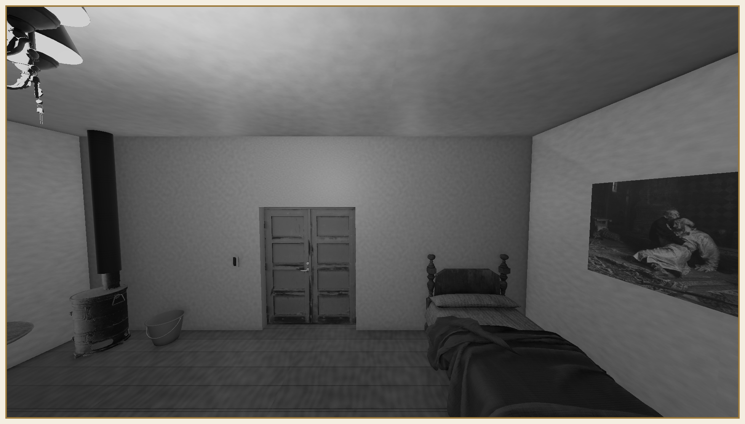
Inside the dream hall — the same desaturation as the waking room, the same wear, further from the door.
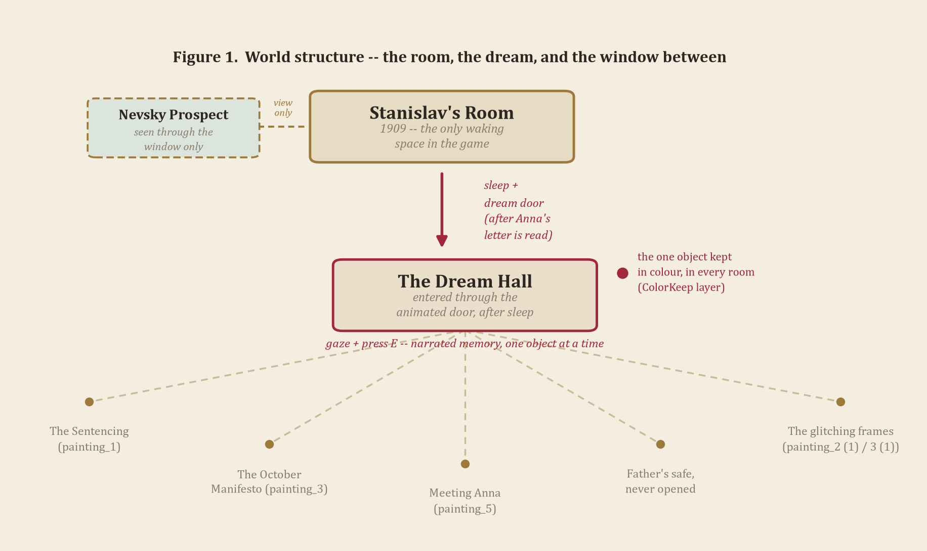

1.2 Non-Player Characters

It would be inaccurate to say “Dear Anna” has no non-player characters. It has several — Anna herself, his brother Nikolai, his cousin Yakov, his mother and father, Anna's own mother — and the decision that shapes the whole prototype is that none of them get a 3D model, a walk cycle, or a line of dialogue delivered to camera. They exist the way they exist for Stanislav: on paper, in a drawer, in a frame on the wall.
This is a deliberate design choice, not a missing feature. A game about a man alone with his correspondence is not under-delivering on “non-player characters” by refusing to put bodies in the room; it would be breaking its own premise if it did. Each correspondent is characterised by what they wrote, what they were photographed doing, or what Stanislav kept of theirs — a wedding ring kept rather than worn (WeddingRing), a family photograph in which “our father managed to get every son to sit still long enough” (painting_2), a second photograph of “Nikolai and I … photographed in our sailor suits, as though the navy were ever going” to take two boys from a St. Petersburg household (photo_4), and a formally posed, deliberately unsmiling portrait of Anna's own mother (painting_4). Anna herself is introduced not by a portrait but by a memory — painting_5's narration recalls the evening they met, with Anna “running the whole gathering herself, arguing with a printer twice her age.”
“The evening I met Anna. She was running the whole gathering herself, arguing with a printer twice her age…”
— narration attached to painting_5
It is worth walking through each correspondent individually, since the catalogue in Table 1 and Table 2 scatters them across several objects rather than introducing them once. Anna is the addressee the title names directly, and the only correspondent the player also meets through a formal portrait (Portrait_StanislavAndAnna) rather than solely through other people's memories of her — fittingly, since she is also the one correspondent whose own letter the entire prototype is structurally built around (GameState.AnnaLetterRead gates the dream itself; see 1.5). Nikolai is Stanislav's brother, met only once in the object catalogue — the sailor-suit photograph (photo_4) — but given a specific, ordinary childhood rather than a symbolic one; the narration's dry aside that the navy “were ever going” to want two Petersburg boys in costume sailor suits is the closest thing in the game to a joke, and it is deliberately the brother's memory that carries it. Yakov, Stanislav's cousin, appears specifically inside the family group photograph (painting_2) rather than in a dedicated frame of his own — present in the fiction, but literally subordinate in the composition to “our father managed to get every son to sit still,” which is as much a description of the photograph's actual subject (the father, the discipline of the sitting) as of Yakov himself.
The parent generation gets the most weight of anyone besides Anna. Stanislav's father owns three separate objects in the catalogue outright — the chess set he “taught all of us on … and never once let any of us win,” the family photograph he arranged, and the safe whose combination Stanislav has “always known” and “never once opened” — which collectively sketch a man characterised entirely through discipline and withholding, never through a portrait of his own face. Stanislav's mother is gentler and more singular: one photograph (photo_3), one specific, almost trivial memory attached to it (an itchy winter hat), present in the narration precisely because it is small. Anna's mother is the one correspondent introduced through formality rather than intimacy — “formally posed and unsmiling, exactly as she insisted on being remembered” — and her death is the single hinge the whole object catalogue turns on without ever showing it directly: WeddingRing's narration places Anna's refusal to wear the ring specifically “the day we buried her mother,” meaning painting_4 and WeddingRing are, underneath their very different cases in Tables 1 and 2, the same afternoon remembered from two different objects.
Mechanically, “talking to” these characters is reading. The letter archive (LetterArchive, living on the GameManager object) and its reader interface (LetterReaderUI) are the game's dialogue system in every sense that matters: they hold the correspondence, track what has and hasn't been opened, and present it back to the player in the character's own words rather than a paraphrase. A conversation in “Dear Anna” is a letter, opened once, and available to revisit for the rest of the game. 2.3 treats this formally as the game's “dialogue” verb.

1.3 Scale

Concrete numbers, gathered directly from the live scene's own colliders and component fields rather than estimated from screenshots. Stanislav's room measures 7.0 by 6.0 metres with a 3.0-metre ceiling — 42.0 m² of floor. The dream hall is both taller in places and dramatically larger in footprint: roughly 8.82 by 13.61 metres of built structure (its walls form an irregular, alcove-driven shape rather than a clean rectangle, per 1.1), for approximately 112.5 m² of floor — close to two and three-quarter times the waking room, even though the objects actually placed in it (Table 2) occupy a shorter near/mid/far stretch of that total depth, leaving real, deliberately unfilled space at the hall's furthest reach.
The player's own scale is set by the CharacterController on the Player object: 1.8 m tall, 0.25 m radius, with a 0.3 m step offset and a 45° slope limit (the last two matter little on the flat floors described in 2.4, but both are configured rather than left at defaults). Figure 2 sets that 1.8 m against the room — a full 1.2 m of headroom to the 3.0 m ceiling — and against a handful of the room's own furniture: the bed frame stands 1.22 m at its tallest point, the writing desk's body 0.72 m, and a pocket watch — the smallest object in the catalogue with a measured footprint — comes in at roughly 0.30 m across, chain included. None of these numbers were chosen for this document; they are simply what the already-built scene measures.
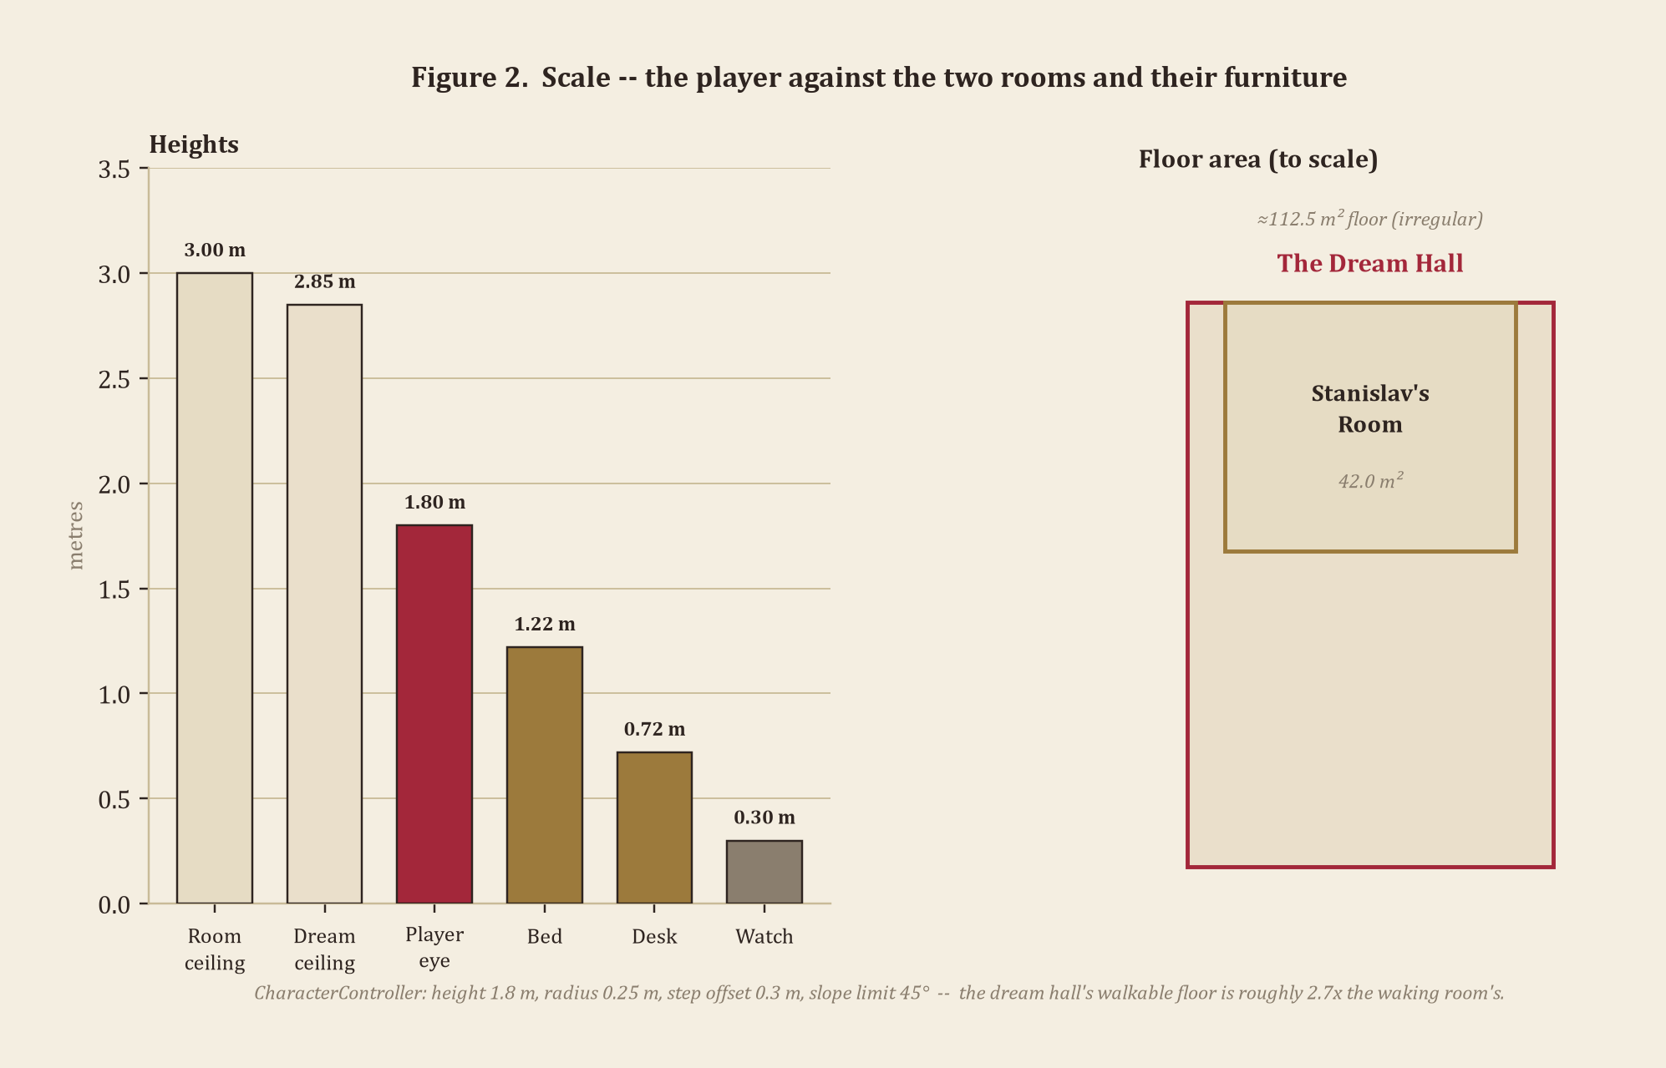

1.4 Temporal Dimension

“Dear Anna” runs on two clocks, and neither of them is a day/night cycle — there isn't one, deliberately. The entire session takes place across a single evening and the dream that follows it, and a game that never leaves one evening has no use for simulating a sun it will never see rise or set. The first clock is real time: a single, uninterrupted sitting, with no fast-forward and no calendar on screen. The second is the story's own, much longer clock, and the two meet at exactly one hinge — sleep.
Sleep is a hard cut, not a slider. The moment Stanislav falls asleep (SleepInteract, gated on Anna's letter having been read — 1.5), the game does not simulate hours passing; it fades to black and comes back inside the dream, with no clock, no calendar, and no indication of how long the “night” inside the dream actually lasts. Time inside the dream hall is explicitly not continuous with time in the room — it is memory, not a place, and memory doesn't keep a clock.
That memory reaches back roughly four years before the game's own present, and the two real historical anchors the fiction is built on sit at opposite ends of that reach. “Dear Anna” is a work of historical fiction, not a history lesson — but it borrows its backbone from two real, dated events. On 22 January 1905 (9 January by the Julian calendar still in civil use in Russia at the time), troops opened fire on an unarmed crowd marching toward the Winter Palace to petition the Tsar, in the massacre remembered as Bloody Sunday. Later that same year, in October, the October Manifesto promised a parliament and civil liberties, and for a season looked as if it might make the spring's violence meaningful.
Stanislav Alexandrovich's story is fictional, but it is built to sit inside that gap between promise and consequence, and it gives him a direct hand in it rather than making him a bystander. The pamphlet the player can pick up and hold (PamphletBook) is his own writing — its narration is blunt about this: “my own pamphlet, the one that put me on the list in the first place.” He is tried and sentenced for it; the sentence is exile to Nizhny Novgorod, several hundred kilometres east of the capital. The letters the player finds and reads are what is left of the years that follow — correspondence standing in for a household that could no longer be in the same room. By 1909, the game's present tense, Stanislav is back in his old room on Nevsky Prospect and the exile is over; what isn't over is easy enough to see in how he spends the evening the game covers, and in why a man who once risked everything on his own words now keeps an inkwell and a full page he can't bring himself to start (InkwellPen).
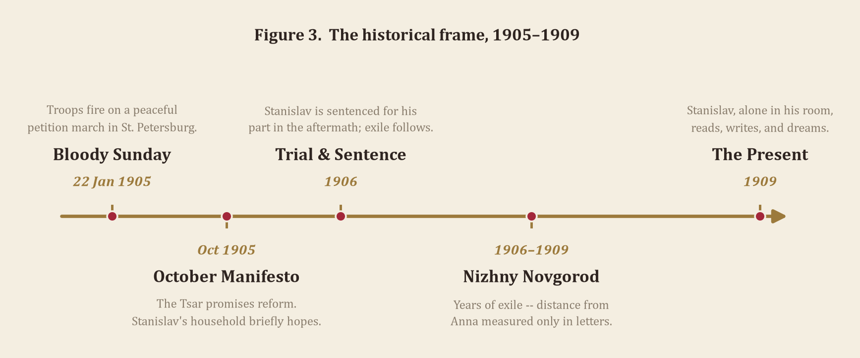
Figure 3 lays out this chronology: two real, dated events at either end, and the fictional arc of sentencing, exile, and return the game hangs on them. The dream-hall narration confirms the order precisely — painting_1, labelled “The Sentencing” in the prototype, places the trial at Nizhny Novgorod “the year before I married Anna,” which is also how this document fixes the marriage relative to the exile.
It is worth being specific about what actually happened on the real calendar this fiction borrows, since the game leans on the gap between the two real dates rather than either one in isolation. On the morning of 22 January 1905, a peaceful procession led by Father Georgy Gapon set out for the Winter Palace carrying icons, portraits of the Tsar, and a petition asking for an eight-hour working day, a living wage, and an elected assembly — asking, not demanding, still addressed to “Nicholas Alexandrovich” as a father figure the crowd trusted to listen. Imperial Guard units fired on that crowd at several points along its route; estimates of the dead range from the low hundreds to over a thousand, and the number matters less, historically, than what broke: a working assumption, widely held until that morning, that the Tsar was separate from and better than the officials beneath him. Within the year, Russia saw its first general strike, the mutiny on the battleship Potemkin, and a wave of unrest severe enough that the October Manifesto was less a gift than a concession — a promise of a State Duma, and of freedoms of speech, assembly, and conscience, issued specifically to buy back the legitimacy Bloody Sunday had spent. Historically, that promise did not hold its shape for long: the Fundamental Laws signed the following spring reasserted the Tsar's personal authority over the new Duma almost as completely as before, and the political opening of late 1905 had mostly closed again within two to three years. “Dear Anna” places Stanislav's trial inside that closing window rather than in the initial crackdown — tried not in the immediate aftermath of January 1905, but once the brief opening the Manifesto offered had visibly started to shut, which is why painting_3's narration can still remember Petersburg believing “it had won,” in the same story that ends in a courtroom at Nizhny Novgorod.
This also sharpens what PamphletBook actually risked. A pamphlet in St. Petersburg in this period was not an abstractly dangerous object — Russia operated under formal pre-publication censorship for most of the nineteenth century, and even after 1905's nominal press freedoms, unlicensed political printing remained the kind of thing the Okhrana (the Imperial security police) built case files around. Stanislav's line that the pamphlet is “the one that put me on the list in the first place” is not melodrama; a paper trail connecting a named author to circulated political writing was, mechanically, how a case like his got built in the first place. It is also why InkwellPen's narration — kept, blank, “everything a letter needs except the courage to start one” — reads as more than a mood line: it is the same risk, declined a second time.
Outside the window, the one piece of the world that belongs to neither the fixed present of the room nor the fixed past of the dream: the carriage and tram on Nevsky Prospect (1.1) loop on their own schedule regardless of what the player does, the game's one small, constant reminder that time has not actually stopped just because the player's has.

1.5 Spatial Boundaries

Every boundary in “Dear Anna” is readable, not just physical — the game would rather show a player why they can't go somewhere than simply stop them silently.
The hard edges are ordinary wall and floor colliders around both the room and the dream hall (1.3), the same kind of invisible geometry any first-person game uses to keep a player inside its built space. More specific to this game are three boundaries built from narrative logic rather than collision alone:
The window is a look-but-never-go barrier. Nevsky Prospect (1.1) is fully visible and animated — the carriage and tram never stop looping — specifically so its inaccessibility reads as a choice about the fiction, not a limitation of the build. There is no door to the street anywhere in the scene.
The bed is a progression gate, not a physical one. Looking at it and pressing E produces no response at all until Anna's letter has been read (GameState.AnnaLetterRead) — not a locked door, not a “you cannot sleep yet” message, simply nothing, because the game is not willing to let Stanislav dream before he's done the reading that provokes the dream.
The dream itself has no way back. Once the door swings open (DreamDoor) and the fade lifts on the dream hall, nothing in the scene offers a return trip to the waking room — no second door, no “wake up” prompt. Figure 1 draws the sleep/dream connection as a single-headed arrow for exactly this reason: structurally, the dream is where the session ends, not a space the player cycles in and out of.

1.6 Object Catalogue

Thirty-one named, catalogued objects make up the full roster a player can pick up, look at, or operate: four hand-held inspectables (Table 1), seventeen gaze-narrated set pieces (Table 2), and ten mechanism and fixture objects (Table 3, including the intro envelope) — past the brief's threshold without needing to count the nine further PinkFlowersPot instances that sit in the room and the dream hall purely as unnarrated set-dressing (1.7). Figure 4 breaks the thirty-one down by interaction type; Tables 1 through 3 list every object individually, each with its gameplay role and the narration text verified directly against its component fields at the time of writing rather than reconstructed from memory.
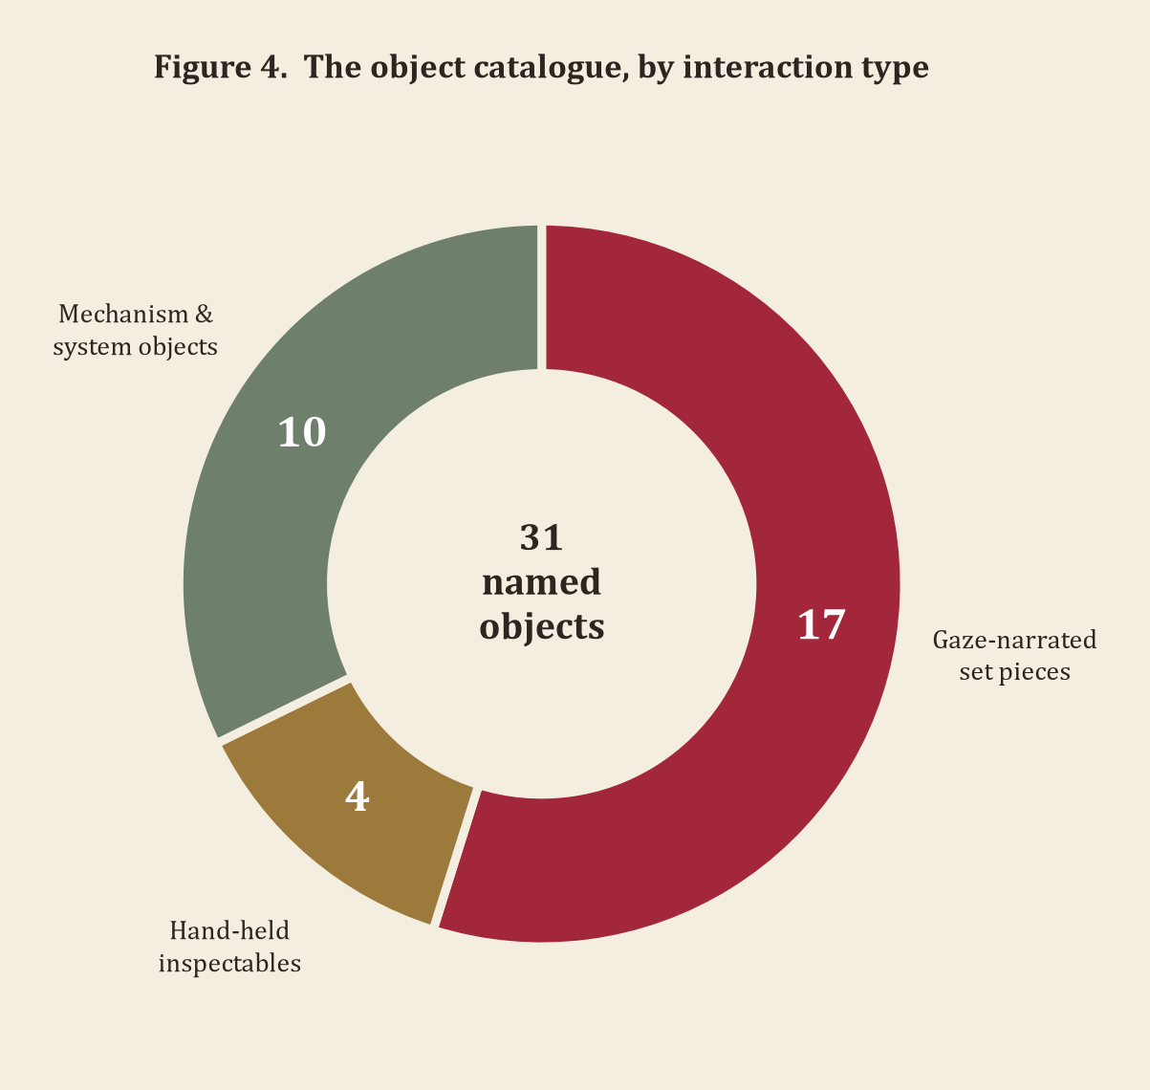

Table 1 — Hand-Held Inspectables (InspectableObject)
Picked up with a click, held and rotated in front of the camera, and put back down with a second click, returning it to its exact original position. Two of the four currently carry narration text; the other two are played as plain physical objects, with no line attached yet.
Object | Role & usability | Narration (verified in-engine)
Pamphlet  (PamphletBook) | Political backstory; picked up, held, read | “My own pamphlet, the one that put me on the list in the first place. I used to think the words were worth whatever came after.”
Wedding ring  (WeddingRing) | Anna's grief, kept; picked up and examined | “Anna's ring. She wouldn't wear it the day we buried her mother — said joy and grief shouldn't share a hand. I think I've carried it more than she ever wore it.”
Pocket watch  (PocketWatch) | Personal keepsake; picked up, no voiced line yet | No narration text assigned yet; read as a plain kept object.
Teacup  (Teacup) | Atmosphere only; picked up, purely incidental | No narration text assigned yet; an ordinary, untouched prop.

Table 2 — Gaze-Narrated Set Pieces (PaintingNarration)
Looked at, then confirmed with E; the component drives every gaze-triggered narration in the game, not only the literal paintings its name suggests. Four of the seventeen — FlowersInVase, the portrait of Stanislav and Anna, the wall clock, and the painting of Ivan the Terrible — are mounted in Stanislav's own room; the rest are reached through the dream hall.
Object | Where | Role | Narration (verified in-engine)
Family photograph  (painting_2) | Dream hall | Family memory | “All of us together, the one time our father managed to get every son to sit still long enough.”
The Sentencing  (painting_1) | Dream hall | Historical / personal hinge | “Nizhny Novgorod, the year before I married Anna. They lined us up and read the sentence…”
The October Manifesto  (painting_3) | Dream hall | Historical anchor | “The Tsar's Manifesto, the day Petersburg believed it had won. I remember the crowds, the flags, strangers embracing…”
Meeting Anna  (painting_5) | Dream hall | Courtship memory | “The evening I met Anna. She was running the whole gathering herself, arguing with a printer twice her age…”
Anna's mother  (painting_4) | Dream hall | In-law, formal memory | “Anna's mother, formally posed and unsmiling, exactly as she insisted on being remembered.”
Glitching frame I  (painting_2 (1)) | Dream hall (far) | Corrupted memory | “The birches are gone. The road is gone. Where the painting used to be there's only this — a tearing, a flicker…”
Glitching frame II  (painting_3 (1)) | Dream hall (far) | Corrupted memory | “My father's hunting scene, or what's left of it. The shapes keep sliding into each other, breaking apart…”
Mother, by photograph  (photo_3) | Dream hall | Family memory | “My mother, the winter she had this taken — I remember that hat itched terribly…”
Nikolai, by photograph  (photo_4) | Dream hall (far) | Sibling memory | “Nikolai and I, the summer our father had us photographed in our sailor suits…”
Ink and pen  (InkwellPen) | Dream hall | Theme object (avoidance) | “Ink, a pen, and a book of blank pages — everything a letter needs except the courage to start one.”
Chess set  (ChessBoard) | Dream hall | Father memory | “My father's chess set. He taught all of us on this board, one at a time, and never once let any of us win.”
The safe  (RetrofittedSafe) | Dream hall (far) | Withheld memory | “My father's safe. I have always known the combination, and I have never once opened it, not even here.”
Flowers, narrated instance  (PinkFlowersPot) | Room & dream hall | ColorKeep motif | “The same pot of flowers, again. I've counted them before — there were ten, always ten, no matter which room.”
The flowers  (FlowersInVase) | Stanislav's room | ColorKeep motif | “The one thing in this room that still has its colour. I don't know why — only that when everything else went grey, this didn't.”
Portrait, Stanislav & Anna  (Portrait_StanislavAndAnna) | Stanislav's room | NPC portrait, unvoiced | No narration text assigned yet; present in the room, silent for now.
Wall clock  (WallClock) | Stanislav's room | Household fixture | “The clock still keeps time. I don't know why that surprises me — it's not as though I asked it to stop.”
Ivan the Terrible, painting  (Painting_IvanTheTerrible) | Stanislav's room | Father memory | “My father's choice, not mine — he liked the subject more than I ever did. A Tsar who loved his son enough to kill him. I used to wonder what kind of love that was supposed to be.”

Table 3 — Mechanism & System Objects
Everything else a player operates rather than reads — furniture, fixtures, and one spawned pickup, each with its own dedicated interaction script.
Object | Script | What it does
Bed (BedFrame_Real) | SleepInteract | Starts the sleep → dream sequence; gated on Anna's letter being read.
Door (AnimatedDoor) | DreamDoor | Swings open into the dream hall once sleep begins.
Chair, at the writing desk (SCAUN_LP) | SitInteract | Sit down / stand up; parented directly to the desk (OldDesk).
Light switch (LightSwitch) | LightSwitch | Toggles the chandelier and swings a lever model to match.
Chandelier (Chandelier) | ChandelierFlicker (added at runtime) | Flickers unevenly for the duration of the dream.
Gramophone (Gramophone) | MusicPlayer | Plays music with a “now playing” prompt; stopped cleanly before sleep.
Writing desk & typewriter (TypewriterReal) | TypewriterInteract | A fill-in-the-blank reply to Anna — seven blanks, three word choices each, composed at the desk and archived as a sent letter (gated on Anna's own letter being read first).
Carriage (Carriage) | StreetVehicleLoop | Loops along Nevsky Prospect, visible through the window.
Tram (Tram) | StreetVehicleLoop | A second, independent looping vehicle on the same street.
Envelope (spawned at session start) | EnvelopeLetter | The game's opening pickup — gaze + E collects it and opens the letter-reading interface, eventually setting AnnaLetterRead.

Nine further placements of the same flower-pot prop exist beyond the single narrated instance already in Table 2 — PinkFlowersPot (1) through (9), confirmed live in the scene, each an individually positioned GameObject on the ColorKeep layer (1.7), silent and non-interactive. They are not counted toward the thirty-one objects in 1.6, since nothing about any of them is narrated or operable; they exist purely as set-dressing that completes the pattern the narrated instance's own line describes — “there were ten, always ten, no matter which room.” Together with FlowersInVase, the ten PinkFlowersPot instances and the one vase make the eleven objects on the ColorKeep exemption layer described in 1.7.
Read side by side, Tables 1 through 3 make a pattern visible that no single row shows on its own: the objects split cleanly along a line between things Stanislav can still touch and things he can only look at. Everything in Table 1 is small enough to hold, and everything in it is personal rather than political — a ring, a watch, a cup, a pamphlet. Everything in Table 2 is fixed to a wall or a table and is, almost without exception, about other people: parents, a brother, a wife, a courtroom. Table 3 is neither — it is the room's own machinery, the furniture, fixtures, and the one spawned pickup a player operates rather than remembers through. The nine silent flower pots belong to none of the three: present, placed, keeping their colour, asking nothing of the player at all. That split was not planned as a taxonomy before the objects were written; it fell out of writing eighteen separate narration lines and noticing, afterward, that none of them crossed the line between handled and merely seen.

1.7 The ColorKeep Motif

The single most deliberate visual decision in “Dear Anna” is also one of its simplest to implement. A global post-processing Volume with a Color Adjustments override strips saturation from the entire rendered frame — not just in the dream, but in Stanislav's room as well. This was a specific choice, confirmed directly against the project at the time of writing: the grey is not a dream effect that switches on and off, it is how Stanislav sees everything now, awake or asleep.
Against that grey, one object is deliberately exempted, everywhere it appears: a vase of flowers (FlowersInVase in the room, and its repeated set-dressing instances of PinkFlowersPot scattered through the room and the dream alike — eleven objects on the exemption layer in total: ten PinkFlowersPot instances plus FlowersInVase itself, confirmed live against the scene's ColorKeep layer). Technically, the exemption is a single Unity render layer named ColorKeep and a RenderObjects feature (ColorKeep_RenderObjects) added to the URP renderer asset, scheduled to redraw everything on that layer after the entire post-processing stack — including the desaturation — has already run. Figure 5 walks through that pipeline: an ordinary opaque pass, the global Volume stripping colour from the result, and the ColorKeep layer redrawn on top in full colour, so the final frame reads grey everywhere except the one motif repeated across every room.
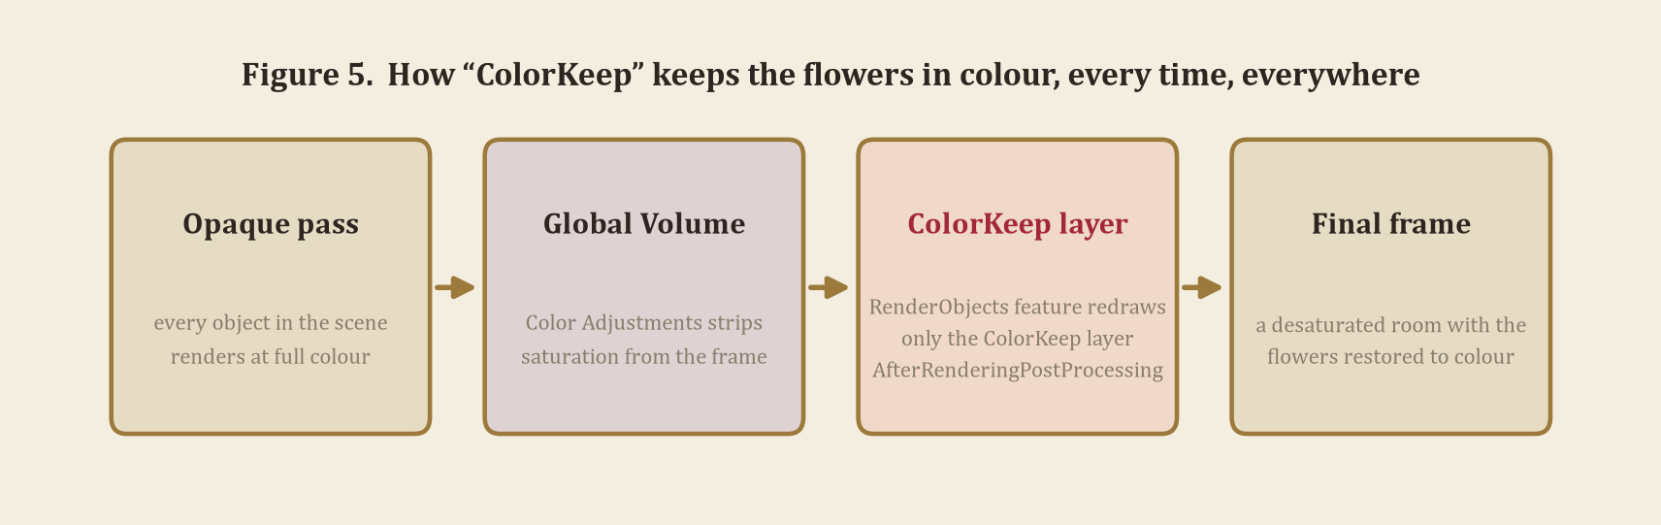
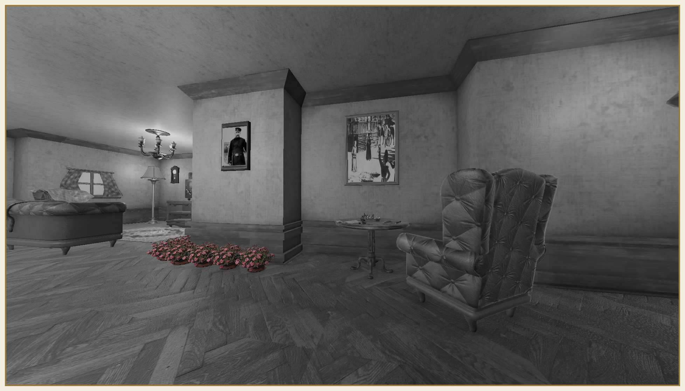
The effect in the running scene, unedited — every surface desaturated except the flowers.
The game is explicit about this in its own writing, not just its rendering. FlowersInVase's own narration line is, almost word for word, a description of the render feature sitting underneath it:
“The one thing in this room that still has its colour. I don't know why — only that when everything else went grey, this didn't.”
— narration attached to FlowersInVase
The flower pots scattered through the dream hall carry a second, stranger line about the same motif — “the same pot of flowers, again. I've counted them before — there were ten, always ten, no matter which room” — which turns a purely technical fact (the same prefab, instanced repeatedly) into a piece of dream logic the player can actually read.
This is also where the brief's art-direction reference photograph earns its place in this document rather than just a mood board. Plate I, below, is the image the brief was built around: a field rendered entirely in black and white but for a single poppy left in colour. It is not a coincidence that it matches the game's own render feature almost exactly — the reference photograph and the game's existing technical solution describe the same idea from two different directions, and this document treats them as the same design decision.
Plate I. The brief's reference photograph — the one object a selective-colour treatment keeps against an otherwise desaturated field. The same principle drives “Dear Anna”'s own ColorKeep render feature (Figure 5).

1.8 A Walkthrough of the Experience

The clearest way to see how the world in 1.1 through 1.7 and the mechanics in Part 2 actually meet in play is to walk through a single uninterrupted session, start to finish, in the order a first-time player encounters it.
The game opens in Stanislav's room with no preamble and no tutorial text. The first thing GameIntro does is spawn an envelope in front of the player and wait; there is nothing else to do until it is picked up, which is itself the first lesson in the game's input language — look, then act — without a single word of instruction on screen. Picking up the envelope opens straight into the letter-reading interface with a voiced reading underneath the text: Anna's letter, the one GameState.AnnaLetterRead will later check for. Only after it finishes does the room itself become worth exploring on its own terms.
From here the session is genuinely open. A player can wind the gramophone and have music under everything that follows; sit down at the writing desk and stand back up; click the light switch and watch the chandelier's lever swing with it; answer Anna at the typewriter, choosing one of three offered phrases at each of seven blanks until the reply is posted and archived alongside her own letter; or simply walk the room's small footprint, picking up the pocket watch, the teacup, the pamphlet, turning each one in hand to see it from every side before setting it back exactly where it was found. The crosshair and the object-naming prompts described in 3.4 do their quiet work here, in the moment before a player has learned the room: without them, a cluster like the writing desk's pamphlet, inkwell, and chessboard would be guesswork to target correctly. Outside the window, the carriage and tram keep looping past on their own clock (1.4), indifferent to whatever the player chooses to do.
The bed does nothing until Anna's letter has been read — looking at it and pressing E produces no response at all before that, deliberately (1.5). Once it is read, the same look-and-press-E opens a different sequence entirely: the screen fades to black, the gramophone's volume fades with it rather than cutting dead, and in the dark the game quietly resets itself for the dream — the record stops turning, Anna's voice-over is force-stopped if it was still somehow playing, and the chandelier's flicker behaviour is attached and enabled. The door is already open by the time the fade lifts; the player wakes up mid-motion, watching the last of it swing, in a room that was never built as a one-to-one copy of the real one but clearly remembers it.
The dream hall rewards exactly the kind of close, unhurried looking the first room taught. A player who only walks its length will see paintings and a locked safe and nothing more; a player who stops at each one and presses E hears Stanislav's own account of what it is, in his own voice. Nothing in the dream hall can be rushed into giving up its content early — every object requires the same gaze-and-confirm patience as the first room, so the hall's eventual revelations (the sentencing, the safe never opened, the two frames that have stopped holding a stable image at all) land only for a player willing to stand still in front of each one. There is no second ending, no failure state, and no score, and — per 1.5 — no way back to the room either; the session simply ends when the player has seen what they came to see, which is, itself, the point being made about Stanislav.

PART 2
Game Mechanics

“Ink, a pen, and a book of blank pages — everything a letter needs except the courage to start one.”
— narration attached to InkwellPen

2.0 Overview

Part 2 moves from what the world contains to what the player can actually do in it: the core actions available at any moment (2.1), movement specifically (2.2), every interaction verb the brief asks about, present or justifiably absent (2.3), navigation and terrain (2.4), weapon usage (2.5), and consumables and resource management (2.6) — followed by the full mechanics catalogue (2.7), the narrative and state machinery that keeps the fiction consistent (2.8), and the design reasoning behind the whole approach (2.9–2.11).

2.1 Player Actions

At any moment outside a menu, Stanislav can do seven things: walk (WASD, gravity-aware, via a CharacterController), look (mouse, yaw on the player body and pitch on the active Cinemachine camera), target whatever is dead centre of the screen (a single-pixel dot crosshair, Crosshair.cs), pick an object up and hold it for a closer look, trigger narration on an object too large or fixed to pick up, and — context-dependently — sit, sleep, toggle a light, read a letter, wind the gramophone, or write one back to Anna, a word at a time, at the typewriter. No two of these share a key by accident; the mapping is small enough that the New Input System's job here is mostly staying out of the way. (This is the general verb list; 3.1 gives the same actions as a concrete cause-and-effect table against actual world state.)
A few of these are worth unpacking individually, since the list above compresses them to a word each. Walking and looking are, mechanically, split across two different owners in a way that is invisible to the player but load-bearing for the Cinemachine migration described in 3.2: FirstPersonMove.cs still turns the player's whole body left and right, because the movement code's WASD direction is derived from that same transform, but it no longer touches vertical look at all — that belongs entirely to CinemachinePanTilt, inherited automatically by the camera's being a child of the body it's rotating with. Picking an object up and triggering narration on one are deliberately two different verbs bound to two different inputs (click versus E) rather than one context-sensitive button, specifically so a player glancing at a painting is never one misplaced click away from accidentally trying to lift it off the wall. The sit/sleep/toggle/read/wind actions are context-dependent in the strictest sense: each is only legible to the player at all once GameState's own gating (2.8) has decided the relevant object is ready to respond, which is why the room never shows a prompt for an action that would currently do nothing.

2.2 Movement Mechanics

There is no running, no jumping, and no climbing in “Dear Anna,” and that is a decision, not a gap: a game about a man reading his own old letters has no use for traversal challenge, and binding verbs the fiction never asks for would only teach a player to expect platforming the rest of the game never delivers. Movement is a single fixed speed — FirstPersonMove.moveSpeed is 3.2 units per second — applied through the CharacterController described in 1.3 (gravity active, no jump input bound to any key). Looking is mouse-only, split as described in 2.1 between horizontal rotation on the player body and vertical look on the active Cinemachine camera. The result reads less like a restricted character and more like an ordinary, unhurried walk through a room someone actually lives in.

2.3 Interaction Mechanics

Every interaction verb “Dear Anna” supports, named individually and explicitly, since earlier drafts of this document left them scattered across several sections rather than answered in one place.

Table 4 — Interaction Verbs
Verb | Present? | How
Pick up | Yes | InspectableObject (Table 1); a click lifts a small object into frame for rotation and examination.
Use | Yes | Context-dependent activation — the light switch, the bed, the chair, the gramophone (Table 3).
Combine | No | Nothing in the catalogue (1.6) is built to be joined with anything else; every object's meaning is already complete on its own.
Discard | Yes, as put-down | A second click returns a held object to its exact original position and rotation (InspectableObject.PutDown).
Dialogue | Yes, as correspondence | Reading a letter (LetterReaderUI) in the correspondent's own words, and writing one back — a fill-in-the-blank reply to Anna composed at the typewriter (TypewriterInteract, Table 3). 1.2 and 2.8 cover this in full.
Trading | No | Nothing in the fiction is bought, sold, or exchanged.
Quest / progression | Yes | The bed will not trigger sleep until Anna's letter has been read (GameState.AnnaLetterRead) — the game's one prerequisite relationship.

2.4 Navigation Across Terrains

Every walkable surface in “Dear Anna” is a flat interior floor — the waking room's wood floor and the dream hall's own (1.1, 1.3) — and there is no terrain variation anywhere in the build: no slopes beyond the CharacterController's unused 45° slope limit (1.3), no stairs, no water, no destructible or deformable ground. The only obstacles are furniture collision (the bed, the desk, the writing-desk chair) and the walls themselves; the only transition between surfaces at all is the dream door (1.5), which is a narrative gate rather than a terrain change. A two-interior-room game has no reason to build terrain variety that will never be walked on, and this document would rather say so directly than leave the absence to be noticed.

2.5 Weapon Usage

There is no weapon of any kind in “Dear Anna,” and no combat system to use one in. This is not an omission the prototype ran out of time to address — a story about a man alone with his own guilt and correspondence has no antagonist to fight, and introducing a weapon would hand the player a verb the fiction has no use for, with no object in the catalogue (1.6) that ever asks them to use it. The closest the game comes to objects with real consequence are PamphletBook and RetrofittedSafe (Table 1, Table 2) — a political pamphlet and a locked safe, both the result of actions long since finished, neither one operable by the player beyond being looked at, or picked up and read.

2.6 Consumables & Resource Management

There is no health, no stamina, no currency, and nothing in the game that is spent, consumed, or replenished. Every object in the catalogue (1.6) persists for the entire session in exactly the state the player leaves it: a picked-up prop goes back exactly where it came from (2.3), a read letter stays read, a lit chandelier stays lit until switched off by hand. Nothing times out, nothing runs low, and nothing needs to be managed — deliberately, since resource management is fundamentally a pressure mechanic, and the game's entire design (2.9) is built around letting a player look at things for as long as they want, rather than against a clock or a meter.

2.7 Mechanics Catalogue

Twenty-three distinct mechanics make up the prototype, grouped in Figure 6 by what kind of problem each one solves. Table 5 lists all twenty-three individually.
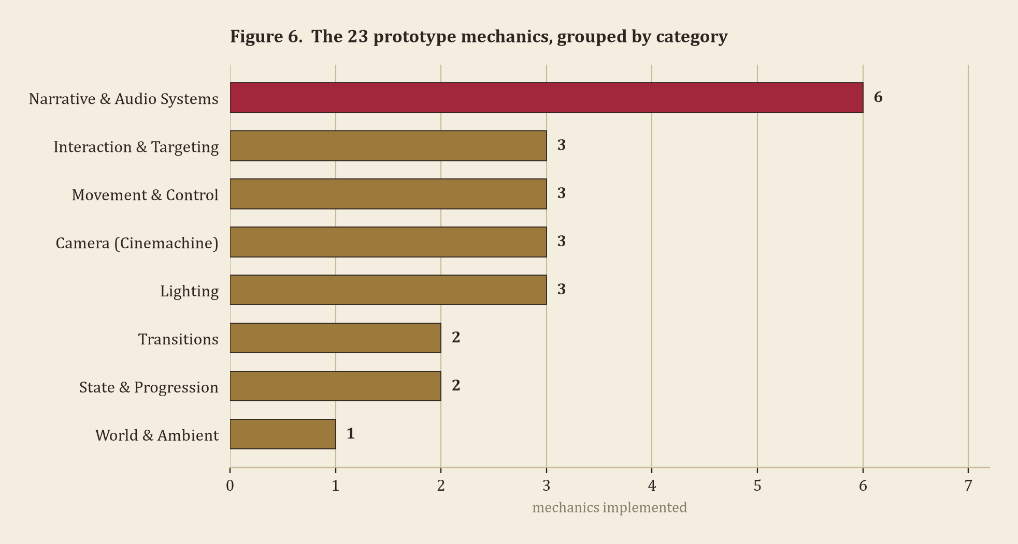

Table 5 — All 23 Mechanics, by Category
# | Category | Mechanic | Effect on the player
1 | Movement & Control | WASD ground movement with gravity (CharacterController) | Moves Stanislav through the room/dream hall at a fixed, deliberate walking speed.
2 | Movement & Control | Split mouse-look: yaw on the player body, pitch on the Cinemachine camera | Lets the player look freely in any direction without affecting movement heading.
3 | Movement & Control | Movement/look locked automatically whenever a UI is open (GameState.IsUIOpen) | Stops the player drifting or spinning while reading a letter or inspecting an object.
4 | Camera (Cinemachine) | First-person CinemachineCamera with CinemachinePanTilt look | Default view; the player sees the world through Stanislav's own eyes.
5 | Camera (Cinemachine) | Memory-focus CinemachineCamera, blended in on gaze+E narration (CM_MemoryFocus) | Pushes in on whichever object is being narrated — centred for wall art, an elevated angle for desk objects — then blends back when the narration ends or Esc is pressed.
6 | Camera (Cinemachine) | Seated CinemachineCamera with its own pan/tilt, blended in while sitting (CM_Seated) | Eases the player's view into the chair rather than cutting to it, with mouse-look still working while seated, and back again on standing up.
7 | Interaction & Targeting | Centre-screen sphere-cast gaze targeting with a dot crosshair | Tells the player exactly what they can act on without needing pixel-perfect aim.
8 | Interaction & Targeting | Object-naming context prompts (“Press E to look closer — X”) | Confirms what the player is about to interact with before they commit to the key press.
9 | Interaction & Targeting | Hand-held inspection: FOV-aware auto-fit framing plus depth-of-field blur | Brings a picked-up object fully into frame and in focus for close examination.
10 | Narrative & Audio | Gaze + E narration with on-screen text and optional voice clip | Delivers the game's story to the player directly from the object being looked at.
11 | Narrative & Audio | Narration occlusion check (a wall blocks narration bleeding between rooms) | Keeps the player from hearing a narration triggered by something they can't actually see.
12 | Narrative & Audio | Letter archive & reader UI (LetterArchive, LetterReaderUI) | Lets the player read each letter's full text on screen, voiced, at their own pace.
13 | Narrative & Audio | Spawned envelope-letter intro sequence with a voiced reading | Opens the session with the one action the player must take before anything else unlocks.
14 | Narrative & Audio | Gramophone playback with a “now playing” prompt, stopped cleanly before sleep | Gives the player optional music and on-screen confirmation of which track is playing.
15 | Narrative & Audio | Fill-in-the-blank reply letter at the typewriter (TypewriterInteract) | Lets the player compose Stanislav's own words back to Anna, one chosen phrase at a time, rather than only receiving hers.
16 | World & Ambient | Looping street vehicles, carriage and tram, independently timed | Makes the view through the window feel alive without inviting the player to chase it.
17 | State & Progression | Centralised gating flags (GameState: IsDreaming, IsUIOpen, AnnaLetterRead) | Determines, moment to moment, which of the player's other actions are currently available.
18 | State & Progression | Sit-down / stand-up state swap at the desk chair | Repositions the player into and out of a seated pose at a single click.
19 | Lighting | Manual click-toggle light switch | Gives the player direct control over whether the room is lit or dark.
20 | Lighting | Randomised chandelier flicker, added for the duration of the dream | Signals to the player, purely through light, that the space they're in is unstable.
21 | Lighting | Global desaturation Volume with ColorKeep layer override | Shows the player a greyed-out world except for the one motif that keeps its colour.
22 | Transitions | Sleep → dream fade sequence with synchronised music fade-out | Carries the player smoothly from the waking room into the dream without a hard cut.
23 | Transitions | Door-opening animation, slowed so it is still visible on wake | Gives the player a visible, readable cue that the dream space has just opened up.

Grouped rather than listed, the eight categories tell a fairly specific story about where the implementation effort actually went. Narrative & Audio is by far the largest category for a reason that should not be surprising for a game about correspondence: it is also the only category with no purely mechanical equivalent elsewhere in the table — nothing in Movement & Control or Interaction & Targeting does its job if the six systems in Narrative & Audio are not all independently working at once, since picking up an object or pressing E is mechanically inert without something to narrate. Camera and Movement & Control sit at three apiece because the brief for a first-person narrative game is almost entirely about restraint here — three mechanics each is close to the minimum that still supports a real Cinemachine blend on two separate triggers (memory focus and seated) alongside the default view, not a ceiling the prototype ran out of time to build past. Lighting holds three mechanics that do three structurally different jobs (a manual switch, a randomised runtime behaviour, and a global render-pipeline override) rather than three variations on one idea, which is why 3.3 treats them as genuinely separate systems instead of one lighting feature with settings.
World & Ambient is the smallest category by design, at one entry: the street's looping vehicles exist to make the room feel inhabited rather than to give the player anything new to solve, and nothing else in the game is purely ambient — even the writing desk, which could easily have been scenery, is instead where the reply-letter mechanic now sits (moved into Narrative & Audio above, since composing Stanislav's reply is a narrative act, not set dressing). State & Progression, at two, is a single idea (GameState's gating flags, and the one piece of furniture — the chair — whose state the player can swap directly) rather than a sprawling save/progression system, because a one-session, no-fail-state game like this one genuinely does not need more state than that to stay coherent. Transitions, at two, covers the sleep fade and the door's own animation specifically — the brief's broader cinematic-transition requirement is satisfied separately, by the memory-focus and seated Cinemachine blends cataloged under Camera (3.2), and the two should not be conflated.

2.8 Narrative & State Systems

A handful of quiet systems hold the whole experience together. GameState is a small static hub of flags — IsDreaming, IsUIOpen, AnnaLetterRead — that every interactive script checks before acting, which is what lets the bed refuse to work before the letter is read, or the player's look and move controls lock cleanly the moment any UI opens. GameIntro owns the game's opening beat: it spawns an envelope prefab (EnvelopeLetter) in front of the player, waits for it to be picked up, and opens directly into the letter-reading interface with a voiced reading of the text — stopped cleanly the moment the player chooses to sleep, so two audio sources are never fighting each other. PaintingNarration, despite the name, drives every gaze-triggered narration in the game, not only the literal paintings; it includes an occlusion check so a narration already playing in one room doesn't bleed through a wall into the next.
TypewriterInteract is the one system here that writes rather than only reads. Once AnnaLetterRead is true, looking at the typewriter and clicking opens a reply letter built from seven fixed segments of Stanislav's own prose with a blank between each — the player is offered three short phrases at a time and chooses one, in order, until all seven are filled. The finished letter is assembled from whichever phrases were chosen and saved into GameState.Archive as a new, outgoing “To Anna” entry, sitting in LetterArchive the same way an incoming letter does. It is not a dialogue tree — the player is never choosing between different things to say so much as different shades of how honestly Stanislav says the one thing he has already decided to write — but it is a real compositional choice with a real, archived result, not a fixed letter dressed up as an interaction.
GameState's three flags are worth tracing through a full lifecycle rather than just naming, since between them they are what makes the walkthrough in 1.8 possible without a single scripted cutscene forcing it. AnnaLetterRead starts false and is set permanently true the moment GameIntro's letter sequence finishes — permanently, because nothing in the game ever has a reason to make Stanislav un-read something. SleepInteract reads that flag every frame before it will even check whether the player is looking at the bed, which is a cheaper and more honest gate than disabling the bed's collider outright: the bed is always physically there, it simply has nothing to say yet. IsDreaming flips true inside SleepInteract's own coroutine, after the fade-out and the hold-on-black but before the fade back in, and nothing currently reads it back except as a semantic marker for future work (Appendix B) — a deliberate seam left in the state machine rather than an oversight. IsUIOpen is the busiest flag by far: every interactive script — SleepInteract, InspectableObject, PaintingNarration, LightSwitch, SitInteract — checks it before acting, and the letter-reader, the sleep sequence, any held-object inspection, and a memory-focus narration shot all set it true for their own duration and restore it false afterward. The result is a single shared switch that keeps exactly one foreground interaction active at a time, without any of those systems needing to know the others exist.

2.9 Design Rationale

A few choices here were deliberate enough to be worth stating outright rather than leaving implicit. Gaze-and-confirm narration (look, then press E) was chosen over a dialogue-box or hotspot-menu interface because it keeps the player's attention on the object itself rather than on a UI floating in front of it — Stanislav is remembering, not browsing. There is no HUD beyond context prompts, consistent with the justified absences in 2.5 and 2.6: nothing in the fiction is threatening Stanislav physically, so the only thing at stake is what he is willing to look at. And almost every mechanic in Table 5 maps to exactly one emotional beat rather than serving several at once — the safe is opened by nothing because it narrates about never being opened; the flowers can't be picked up because the point is that they are the one thing that doesn't need to be held onto in order to be kept.

2.10 Design Precedents

“Dear Anna” did not arrive at gaze-and-confirm narration, an object-based memory structure, and a no-fail, no-combat session length in a vacuum; it sits in a reasonably well-established lineage of first-person narrative games, and it is more useful to name that lineage directly than to imply the design was invented from nothing. Gone Home (The Fullbright Company, 2013) is the clearest ancestor of the object-triggered narration model: a house full of ordinary objects, each one capable of surfacing a short piece of voiced narration when examined, with the plot assembled entirely out of what the player chooses to pick up and in what order. “Dear Anna” borrows that structure directly, with one deliberate difference — Gone Home's objects are mostly diegetic documents the player reads silently, while this prototype routes almost everything through Stanislav's own voiced first-person narration, so the player is always hearing one specific consciousness's account rather than assembling the story independently from primary sources.
Dear Esther (The Chinese Room, 2012) and Firewatch (Campo Santo, 2016) supply the other half of the lineage: a single, fixed, unreliable-to-some-degree narrator whose voice is the primary carrier of the story, walking through a space that means more to him than it does to the player on first arrival. “Dear Anna” is closer to Firewatch's model than Dear Esther's in one specific respect — Firewatch's narration is triggered by player action (examining objects, reaching locations) rather than playing on a fixed timer the way Dear Esther's does, and this prototype follows that choice exactly, for the same reason: a fixed-timer narration would force pacing onto a player instead of respecting the unhurried looking the dream hall specifically asks for in 1.8. What Remains of Edith Finch (Giant Sparrow, 2017) is the closest precedent for the family-through-objects structure of Table 2 specifically — an inventory of relatives known almost entirely through the physical traces of their deaths and habits, rather than through any of them appearing as a controllable or even fully rendered character.
A more recent and more tonally specific precedent is Mouthwashing (Wrong Organ, 2024), a first-person narrative game told by a narrator whose account of his own guilt cannot be fully trusted, structured around fragmented, non-linear memory rather than a straight timeline. “Dear Anna” borrows that instability directly rather than only the object-narration format: the two corrupted picture frames in the dream hall (Table 2, 3.5) are this prototype's version of the same idea, a memory that has started visibly failing to hold its own shape, and Stanislav's account of himself throughout is that of a man who wrote the pamphlet that cost him everything and still, in his own narration, cannot fully say so plainly.
Where “Dear Anna” departs from all five precedents is scale and session length. Each of those games is built to occupy thirty minutes to several hours and to be played once, start to finish, as a complete artifact. This prototype, as Assignment 2 of a staged coursework brief rather than a finished shipped game, is deliberately a vertical slice — two bounded spaces (1.1) and a correspondingly smaller object count (1.6) — built to demonstrate the same structural ideas (object-triggered first-person narration, a single voice carrying the story, no combat or fail state) at a scope that can be fully implemented, tested, and documented inside the assignment's timeline, rather than at the scale its genre precedents eventually reached.

2.11 Accessibility & UX Considerations

Several choices made for narrative reasons elsewhere in this document also happen to lower the floor for how carefully a player has to move or aim. The sphere-cast gaze targeting described in 3.4 (a 0.3–0.35 unit radius, not a pixel-thin raycast) exists primarily so small props don't demand pixel-perfect aim, which doubles as a meaningful concession for players with less precise mouse control. The object-naming prompts (“Press E to look closer — the chess set”) that were added mid-project to resolve a sighted-player confusion problem (crowded objects being hard to tell apart) do the same job for a player relying on prompt text rather than on recognising a prop's silhouette at a glance. There is no timed failure state anywhere in the game, no narration a player can be too slow to catch before it's gone and gone for good — PaintingNarration and InspectableObject both hold their text on screen for a fixed duration (displayDuration / narrationDuration) but the player can simply press E again to replay it, and nothing is ever lost by taking too long.
Two gaps are honest enough to name rather than leave implicit. First, narration is currently text-and-optional-voice-clip with no separate option to disable the on-screen text once a voice line is recorded, and no subtitle styling pass (size, contrast, background panel) beyond PaperUtil's existing greeting-style font — a real accessibility gap for low-vision players that a later pass should address directly rather than treat as cosmetic. Second, every interaction in the game is currently bound to a fixed key (E, V, WASD, left click) with no remapping UI, which the New Input System itself supports architecturally but which this prototype has not yet built a front end for. Both are scoped as future work (Appendix B) rather than silently absent.

PART 3
Prototype Implementation

“The birches are gone. The road is gone. Where the painting used to be there's only this — a tearing, a flicker.”
— narration attached to painting_2 (1)

3.0 Overview & Toolchain

Part 3 describes the Unity prototype itself: a concrete player-actions table (3.1), the camera system (3.2) and lighting (3.3), the interaction and targeting architecture underneath every object in Tables 1–3 (3.4), the picture-frame geometry system (3.5), and how the project and scene are organised (3.6).
The prototype runs in Unity 6000.6.2f1 on the Universal Render Pipeline, using Unity's New Input System exclusively, and Cinemachine 3 for all camera work — distributed under package version 6.6.0, Unity 6's own build-version string for this package rather than a Cinemachine version number in its own right. Nothing in the interaction, narrative, or state layer depends on a render-pipeline feature beyond the ColorKeep render feature described in 1.7; URP was chosen specifically for the post-processing Volume stack that effect depends on.
The project's own package manifest fixes the dependency surface precisely: beyond URP and Cinemachine, the only other packages the game logic depends on are the Input System itself and Unity's standard TextMeshPro and Timeline packages pulled in as URP's own dependencies rather than used directly. No third-party asset-store dialogue, save, or interaction framework sits underneath any of the systems in Part 2 — GameState, LetterArchive, InspectableObject, and PaintingNarration are all original MonoBehaviours written for this project specifically, which keeps the whole interaction layer auditable from the twenty-three scripts in Assets/Scripts (Appendix A) rather than spread across an external package's own source.
Scripting throughout the project targets Unity's default .NET profile with no unsafe code and no custom native plugins; every behaviour described in Part 3 is a plain MonoBehaviour or, in FramePictureCore's case (3.5), a static Editor-only utility class. Physics is used narrowly and consistently — every gaze interaction in the game is a Physics.Raycast or Physics.SphereCastAll call against the scene's existing colliders, never a trigger-volume or custom proximity system, which is why 3.4 can describe one targeting pattern and have it cover every interactive object in Tables 1 through 3 without exception.

3.1 Player Actions

Where 2.1 lists the verbs available to a player in general terms, this table gives the same actions as concrete cause and effect — exactly what input produces exactly what change in world state — placed here, in the prototype section, specifically so it can be checked against the running project rather than against prose alone.

Table 6 — Player Actions, Cause → Effect
# | Action (input) | Effect on world state
1 | Click the light switch | Chandelier Light.enabled toggles; the switch's lever model rotates to match (LightSwitch).
2 | Gaze + E on the spawned envelope | Envelope is collected; the letter-reading interface opens with a voiced reading; GameState.AnnaLetterRead is eventually set true (GameIntro, EnvelopeLetter).
3 | Gaze + E on the bed (post-letter) | Screen fades out; GameState.IsDreaming is set true; the dream door opens; screen fades back in inside the dream hall (SleepInteract, DreamDoor).
4 | Look at the gramophone + left-click | Record advances to the next track (or starts the first); a “now playing” prompt appears on screen; playback is force-stopped cleanly before sleep (MusicPlayer).
5 | Click the chair at the writing desk | Player position and rotation swap to a seated pose; the camera blends into the seated vantage (CM_Seated, 3.2), which keeps its own look control; pressing E stands the player back up and blends the camera back (SitInteract).
6 | Click a hand-held object (Table 1) | Object parents to the camera, scales and frames itself in view; a second click returns it to its exact original transform (InspectableObject).
7 | Gaze + E on a narrated object (Table 2) | On-screen narration text (and, where recorded, a voice clip) displays for a fixed duration; the camera blends into a framed shot of the object (CM_MemoryFocus, 3.2), locking movement and look for the duration; GameState.IsUIOpen is held true, and Esc cancels early (PaintingNarration).
8 | Look at the typewriter + left-click (post-letter), then choose a word, seven times | A reply letter is composed one blank at a time from the chosen words; on the final choice it is built and archived as a sent “To Anna” entry in GameState.Archive (TypewriterInteract).

3.2 Camera

Camera work in “Dear Anna” is built entirely on Cinemachine, specifically so every transition between views is a real blend rather than a cut. The brief's own camera-behaviour requirement lists first-person, third-person, and a blending/priority transition as examples of what counts, not a fixed checklist — this project implements three distinct behaviours chosen to fit a slow, first-person memory game rather than to tick off every example literally. There is no third-person view: nothing in “Dear Anna” is ever meant to be seen from outside Stanislav, so a behaviour that exists only to show his own body from a distance has no place in it. Table 7 lists the three actual behaviours; the rest of this section describes how each is built.

Table 7 — Camera Behaviours
Behaviour | Component | What it does
First-person | CM_FirstPerson (CinemachineCamera + CinemachinePanTilt) | Default view; vertical look driven by mouse delta via CinemachineLookInput.
Memory focus | CM_MemoryFocus (CinemachineCamera, transform-driven) | A one-shot framed shot on whichever object is being narrated, locking movement and look; blends in on E, blends back out when the narration ends or Esc is pressed.
Seated | CM_Seated (CinemachineCamera + CinemachinePanTilt) | Eases the view into the chair when the player sits, instead of cutting, and keeps mouse-look working while seated.

CameraRig.cs (on the Player object) owns all three CinemachineCamera instances and switches which one is enabled — the same mechanism every time, since CinemachineBrain, on the main camera, blends smoothly between whichever camera currently holds priority rather than cutting. CM_FirstPerson and CM_Seated are both children of the player, each carrying its own CinemachinePanTilt and CinemachineLookInput adapter for vertical look, so mouse-look works identically in both — standing or seated, the player can look around freely, and CM_Seated inherits the same horizontal yaw the player's own body rotation already drives through the ordinary parent-child transform relationship; FirstPersonMove.cs itself only ever turns the player body on the horizontal axis. CM_MemoryFocus is the one camera that isn't parented or steered by a look component at all: it's a bare, transform-driven CinemachineCamera that PaintingNarration repositions directly each time a gaze+E narration starts, framed one of two ways depending on what kind of object it is — a straight-on, centred shot along the object's own forward axis for flat, wall-mounted art (paintings, photographs, the portrait, the clock), or an elevated three-quarter shot, pulled back and lifted above the object, for anything freestanding on a surface (the inkwell and paper, the chess set, the safe, the flowers), derived from whichever side of the object the player is actually standing on rather than the object's own orientation. One memory-focus camera is reused across all seventeen narrated objects this way, repositioned fresh each time, rather than built once per object. Movement and look are frozen for the length of a focus shot (fpm.canMove/canLook) and GameState.IsUIOpen is held true, so the player can't drift out of frame while it's holding; pressing Esc cancels early and blends straight back to first-person, with an on-screen prompt confirming the option. Sitting down at the writing desk works the same way in reverse: movement locks (the player doesn't walk from a chair) but look does not, which is what lets a seated player look down at the typewriter rather than staring at a fixed point.
All three cameras originally inherited Cinemachine's default 40° field of view, which turned out to cause two separate problems at once: visually, the view read as unnaturally narrow and zoomed in; functionally, InspectableObject's hand-held framing math (FrameHeldObject) reads the active camera's field of view directly to size a picked-up object against the screen, so the same narrow lens that looked wrong was also actively breaking the fit calculation for anything the player picked up. Figure 7 shows why — the same object, at the same distance, fills far more of a 40° frame than a 75° one. All three cameras are now set to a 75° field of view, which reads as a natural first-person lens and restores the inspection framing to working order.
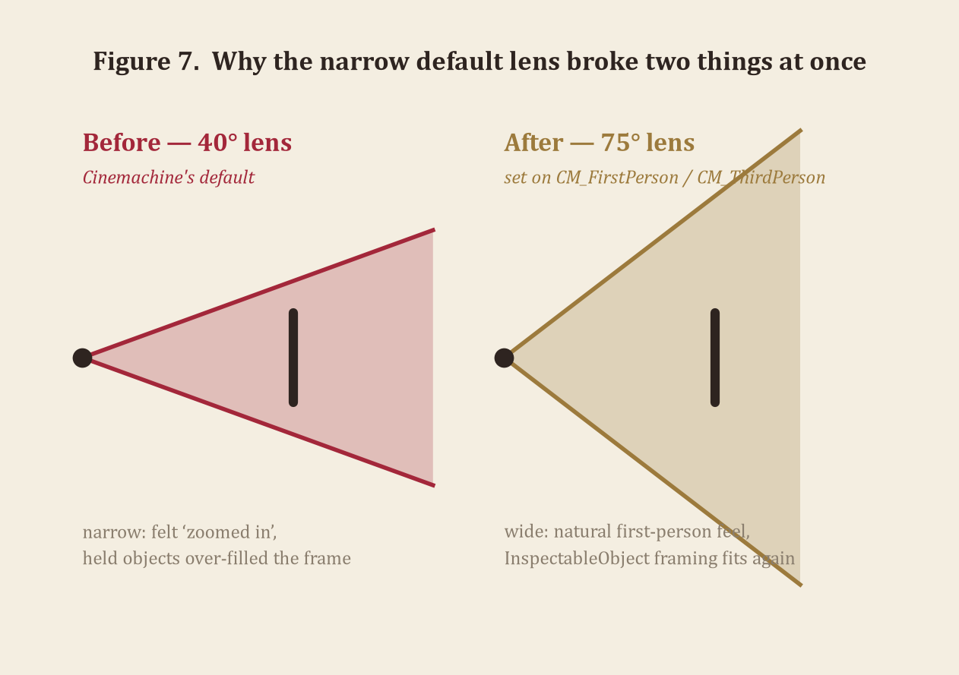
The camera also stays exactly where the player left it through the entire sleep-to-dream transition: SleepInteract fades the screen to black, the dream begins behind the fade, and the door (DreamDoor) is already swinging open by the time the fade lifts, slowly enough — just over four seconds — that the player wakes up watching the last of it move. No cut, no separate camera angle, and no camera movement the player didn't cause themselves is ever used; the door's own animation carries the moment.

3.3 Lighting

Three distinct, independently implemented lighting behaviours exist in the prototype:

Table 8 — Lighting Behaviours
Behaviour | Script | How it works
Manual switch | LightSwitch.cs | Looking at the switch and clicking toggles the chandelier's Light component on and off and swings a small lever model to match, with prompt text reflecting the current state.
Randomised flicker | ChandelierFlicker.cs | Added to the chandelier at the exact moment the dream begins and removed cleanly afterward: every 20–120 ms it re-rolls each light's intensity to somewhere between 5% and 180% of its resting value.
Global desaturation + ColorKeep | URP Volume + RenderObjects feature | A Color Adjustments override on a global Volume strips saturation from the entire rendered frame; a RenderObjects feature (ColorKeep_RenderObjects) redraws one Unity layer in full colour after the post-process stack runs. Full pipeline diagram in 1.7, Figure 5.

The third behaviour is a renderer-level effect rather than a single fixture, and it is worth describing precisely rather than arguing for. It runs on every frame of every session, in both the room and the dream hall alike, as a Color Adjustments override on a Volume component with global scope — the same category of effect URP itself documents as post-processing, applied here to the entire scene's lighting output rather than to one light source. A second, independent render pass (the ColorKeep RenderObjects feature) then selectively redraws one Unity layer back to full saturation after that global pass has already run — a compositing step, not a second lighting pass — which is what produces the one-object-in-colour result described in 1.7. Structurally, it is the most significant of the three lighting behaviours in this table: unlike the switch or the flicker, which affect a single fixture, this one determines what every light in both scenes actually looks like once rendered, for the whole of every session.

3.4 Input & Interaction Architecture

Every gaze-based interaction in the game — narration, the bed, the light switch, sitting down — shares the same underlying pattern: a sphere-cast from the exact centre of the viewport (wide enough that small props like a ring or a watch don't need a pixel-perfect crosshair), checked against whatever the player is looking at, with a single-pixel dot crosshair (Crosshair.cs) always on screen as the player's only targeting reticle. On-screen prompts are written to name the specific object in view rather than a generic “Press E,” specifically because an earlier version of the room — dense with paintings, photographs, a chessboard, and a pamphlet within a few degrees of each other — made it genuinely unclear which object a narration was about to trigger on; naming the object directly in the prompt (the displayName field shared by InspectableObject and PaintingNarration) resolved that ambiguity without changing any of the underlying targeting code.
Picked-up objects go through more than a simple parent-and-scale swap. InspectableObject.FrameHeldObject computes the object's true visual bounds (not just its pivot, which can sit well off-centre on an imported mesh), scales it to fill a configurable fraction of the screen regardless of its real-world size, and then shrinks both the object and its distance toward the lens together — which keeps the on-screen framing identical while letting the prop sit closer than any desk or wall could physically get, so nothing clips through it. A dedicated, high-priority Volume adds Gaussian depth-of-field behind the object for the duration of the hold, so the rest of the room softens out of focus exactly the way a hand-held object would pull real focus toward itself. The nearest point of a held object is kept at a fixed 0.04 units from the lens, which is why both Cinemachine cameras (3.2) are set to a 0.01 near clip plane — close enough that nothing picked up is ever clipped by the camera's own near plane, no matter how large it was before being scaled down to hand-held size.
PaintingNarration's occlusion check (2.8) is worth tracing in full, because it solves a problem that is easy to under-rate until it goes wrong: a sphere-cast wide enough to make small, flush-mounted frames easy to target is also wide enough to hit things it shouldn't. The check first confirms the player's own object is among the sphere-cast's hits and records its distance, then walks every other hit in the same cast looking for anything nearer; a hit under 0.05 units is explicitly ignored no matter how close it is, because at that range it almost always means the casting sphere's own starting volume is already touching a nearby wall or desk edge — the camera standing close to furniture, not something genuinely in the way. Anything beyond that threshold but still nearer than the target object blocks the interaction outright. The distinction matters in exactly the cluttered desk scenario that motivated the displayName prompts in the first place: without the 0.05-unit carve-out, simply standing close to the writing desk to read the chessboard could have silently disabled it, for a reason no player could have diagnosed by looking.

3.5 Picture-Frame Geometry (FramePictureCore)

Every framed picture and photograph in Table 2 — ten objects in total — is placed by a single shared system, FramePictureCore.PlaceImage, rather than by hand-positioning a textured quad per frame. It runs once, at edit time, against whatever 3D frame model has been dropped into the scene, and the problem it solves is harder than it sounds: a frame sourced from an external asset pack has no metadata about where its own picture opening is, what direction it faces, or how large it is in world units, and several of the frames used in this project were imported already tilted back against a wall rather than sitting flat.
The method's solution is to read the geometry itself rather than trust the asset's transform. It clusters every vertex normal on the frame's mesh into buckets, keeps the single largest cluster as the candidate picture face, finds whichever other cluster points most directly opposite it (the same flat surface's other side), and then picks whichever of the two actually faces into the room rather than the wall behind it, using a configurable interior-facing hint. A first measurement pass takes the strict bounding box of that cluster's vertices; a second pass then widens that box slightly, pulling in nearby vertices whose normals are close enough to the picture plane but were excluded from the strict cluster because a smooth-shaded bevel at the opening's rim had blended their normals — gated to a small fixed 3.5 cm slack rather than a percentage of the frame's size, specifically because an earlier, proportional version of that slack nearly doubled the measured opening on a large frame. Skipping this second pass was tried and reverted during development; without it, several frames rendered their picture very slightly undersized, with a visible gap between the image and the moulding around it.
Once the opening is measured, the image itself is either cover-cropped to fill it exactly (the default, computing a UV sub-rectangle from the frame's and image's respective aspect ratios around a configurable focus point, so an off-centre subject isn't accidentally cropped out) or, for photographs whose aspect is too far from the frame's to crop sensibly — a group portrait in a landscape opening, for instance — shown in full with the canvas itself resized to the image's own aspect instead, leaving a sliver of the opening visible at the narrow sides rather than cutting anyone out of the photograph. The final quad is built directly in world space from the frame's own measured right/up basis vectors, with UVs matched to its corners one-to-one, which avoids relying on any primitive mesh's built-in UV layout or rotation convention — a deliberate choice after an early version, built on a scaled default quad, produced mirrored or rotated images on a few of the externally sourced frame models.
Two picture frames deep in the dream hall (painting_2 (1) and painting_3 (1)) use the same system to show something deliberately unstable: a static glitch-pattern image rather than an ordinary photograph, reusing the same baked frame geometry and cover-crop placement as every other picture in the game. The narration on both frames describes corruption and tearing directly — “the birches are gone, the road is gone,” “the shapes keep sliding into each other” — matching what is actually on the wall rather than describing an effect the image doesn't show.

3.6 Scene & Project Organization

The project keeps a small, flat set of top-level Assets folders rather than a deep nested hierarchy: Scripts holds all twenty-three C# files referenced throughout Part 3 in one unsorted folder, small enough that a per-system subfolder structure would add navigation overhead without actually clarifying anything; ExternalModels holds every sourced 3D asset (the door, carriage, chessboard, envelope, flower vase and pots, inkwell and pen, mannequin, palace and apartment-block facades, period windows, phone booth, pocket watch, and the rest of the set-dressing credited in full at the end of this document) each in its own named subfolder exactly as imported, so a model's licensing and origin stay traceable back to its source pack; Textures/DreamExhibits holds the materials FramePictureCore (3.5) generates and reuses for every framed picture; and Settings holds the URP asset and renderer data the ColorKeep feature (1.7) is attached to. Editor holds exactly one file — SetupColorKeepRenderFeature.cs, the one-off menu command that adds the ColorKeep RenderObjects feature to the renderer — kept separate from Scripts specifically because it depends on UnityEditor and must never ship in a build.
The scene itself (SampleScene) is organised around a handful of root-level grouping objects rather than one flat list of hundreds of GameObjects: Fixtures holds room furniture that is never picked up or relocated (the chandelier, the light switch, the gramophone, the Stanislav-and-Anna portrait); SmallObjects holds the hand-held inspectables and the desk's immediate contents; and the desk itself (OldDesk) directly parents its own chair (SCAUN_LP), which is why Table 3 can describe the chair as belonging to the desk rather than sitting independently in the room. The dream hall's paintings, photographs, and FramePictureCore-generated canvases sit under their own grouping rather than mixed into the waking room's hierarchy, which keeps 1.1's and 1.3's reading of the dream hall's depth legible directly from the Hierarchy window, not just from world-space coordinates.
Two objects in the catalogue (1.6) are built as reusable prefabs rather than one-off scene objects, specifically because the scene needs more than one instance of each: PinkFlowersPot (ten placements across the room and the dream hall, 1.6, 1.7) and EnvelopeLetter (spawned fresh at the start of every session by GameIntro, rather than hand-placed in the scene, 2.8). Keeping both as prefabs means a single edit — the flower-pot model, or the envelope's pickup behaviour — propagates to every instance at once.

PART 4
Compliance Overview

“My father's safe. I have always known the combination, and I have never once opened it, not even here.”
— narration attached to RetrofittedSafe

4.0 Requirement Coverage

The table below checks this submission against the brief's own requirement list, item by item, with a count against each threshold where the brief gives one. Every figure, count, and script name referenced in this table was checked directly against the live project rather than against an earlier draft of this document.
Brief requirement | Status | Where
Locations | Met — two bounded spaces, fully described | §1.1, Fig. 1
Non-player characters | Met — six correspondents, framed as letters/memories by design | §1.2
Scale | Met — room and dream-hall dimensions, player and prop sizes, in metres | §1.3, Fig. 2
Temporal dimension | Met — real-time session, hard sleep cut, historical anchor | §1.4, Fig. 3
Spatial boundaries | Met — window, letter gate, one-way dream, all explained | §1.5
Objects: 30 minimum | 31 / 30 ✓ | §1.6, Fig. 4, Tables 1–3
Movement mechanics | Met — stated plainly, including what's absent and why | §2.2
Interaction mechanics | Met — all seven brief verbs addressed individually | §2.3, Table 4
Navigation across terrains | Met — flat interiors, justified absence of terrain variety | §2.4
Weapon usage | None — explicitly justified against the narrative's premise | §2.5
Consumables & resource management | None — explicitly justified, same treatment as weapons | §2.6
Mechanics: 20 minimum, described in detail | 23 / 20 ✓, each with an effect-on-player note | §2.7, Fig. 6, Table 5
Player actions: 5 minimum | 8 / 5 ✓, plus a cause-and-effect table in Part 3 | §2.1, §3.1, Table 6
Camera: 3 behaviours | 3 / 3 ✓ — first-person, memory-focus blend, seated blend | §3.2, Table 7, Fig. 7
Lighting: 3 behaviours | 3 / 3 ✓ — manual switch, randomised flicker, global render override | §3.3, Table 8
Engine implementation matches documented design | Verified live against the project at time of writing | §3.0 onward

A few rows are worth a sentence of self-assessment rather than a bare checkmark. The object count clears the threshold on named, interactive objects alone, without counting the nine further silent flower pots (1.6) toward it — thirty-one objects a player can pick up, look at, or operate, against a world of two bounded rooms, which is a dense object-to-room ratio by design, since an epistolary game's whole argument depends on the room rewarding close attention rather than quick traversal. The lighting row is the one this document is most confident about: the three behaviours in Table 8 are not three settings on one system but three structurally unrelated ones — a UI-driven toggle, a randomised runtime behaviour, and a render-pipeline-level override — and 3.3 describes the third one as what it technically is rather than arguing for why it should count. The camera row is the one most worth reading 3.2 in full for rather than taking the table's word on: the brief's own example language is “switch between virtual cameras” and “zoom on interaction,” and CameraRig's enable/disable swap between CM_FirstPerson, CM_MemoryFocus, and CM_Seated is a literal, not approximate, description of the first, with the memory-focus camera itself being a literal instance of the second.

Appendix A — Script Registry

For reference, every script in Assets/Scripts at the time of writing, with its primary responsibility in one line. Several are cross-referenced by name throughout Parts 1 through 3; this table exists so the full set can be checked at a glance against those references.
Script | Responsibility
GameState | Static hub of shared flags: IsDreaming, IsUIOpen, AnnaLetterRead (§2.8)
FirstPersonMove | WASD movement and horizontal look; vertical look delegated to Cinemachine (§2.1, §3.2)
CameraRig | Owns the first-person, memory-focus, and seated CinemachineCameras and switches which is live (§3.2)
CinemachineLookInput | Mouse-driven vertical look adapter for CinemachinePanTilt (§3.2)
Crosshair | Draws the centre-screen targeting dot (§3.4)
InspectableObject | Hand-held pickup, framing, rotation, and depth-of-field blur (§3.4)
PaintingNarration | Gaze-and-confirm narration, with occlusion checking and the memory-focus camera trigger (§2.8, §3.2, §3.4)
FramePicture | Inspector-facing wrapper that invokes FramePictureCore (§3.5)
FramePictureCore | Edit-time frame-opening measurement and image placement (§3.5)
LightSwitch | Manual chandelier toggle (§3.3)
ChandelierFlicker | Randomised light-intensity flicker during the dream (§3.3)
SitInteract | Sit-down / stand-up state swap at the desk chair (§2.7)
SleepInteract | The sleep → dream transition sequence (§1.5, §2.7)
DreamDoor | The dream hall's door-opening animation (§1.1, §3.2)
TypewriterInteract | Fill-in-the-blank reply letter to Anna, archived into GameState.Archive (§2.3, §2.8)
StreetVehicleLoop | Looping ambient street traffic (§1.1)
GameIntro | The opening envelope-and-letter sequence (§2.8)
EnvelopeLetter | Runtime-spawned pickup component for the intro envelope (§1.6, §2.8)
LetterArchive | Central store of collected letters and their read state (§1.2, §2.8)
LetterReaderUI | The letter-reading interface (§1.2, §2.8)
MusicPlayer | Gramophone playback and its “now playing” prompt (§1.1)
PaperUtil | Shared GUIStyle definitions for the game's paper-and-ink text styling
SetupColorKeepRenderFeature | Editor-only one-off: adds ColorKeep_RenderObjects to the URP renderer (§1.7)

Appendix B — Future Work

Scoped deliberately out of this submission, in rough priority order: subtitle styling and an on-screen toggle for narration text, independent of whether a voice clip is attached (§2.11); an input-remapping front end for the bindings the New Input System already supports structurally (§2.11); narration and voice lines for the three objects currently silent — PocketWatch, Teacup, and Portrait_StanislavAndAnna (Tables 1–2); and giving GameState.IsDreaming an actual reader, most likely a dream-specific ambient audio bed distinct from the waking room's, now that the flag (§2.8) is already in place for it.
A more structurally ambitious direction, well beyond a vertical-slice prototype but worth naming because the existing architecture already points toward it: a small chore mechanic at the writing desk and around the room — straightening the pamphlet, resetting the chess set, tidying the desk — that would give the room's “maintained, lived-in” quality (1.1) something the player actually does, rather than only something the narration describes.
The furthest extension of the reply-letter idea already built for the typewriter (TypewriterInteract, §2.3, §2.8) is a second, inward-facing fill-in-the-blank mechanic at the same desk: not another letter to Anna, but a private journal — Stanislav writing to himself. Specific words or short phrases in that text would be left open for the player to choose from a limited set of options the same way the reply to Anna already works, but the content would be confession rather than correspondence, surfacing what Stanislav is willing to admit to himself and not only to her. The accumulated pattern of those choices across a session — more remorseful, more defensive, more evasive — would decide which of several distinct endings the session resolves to, giving “Dear Anna” genuine branching endings built entirely out of word choice rather than a separate dialogue-tree system. None of this is built in the current submission; it is named here specifically because GameState's gating flags and LetterArchive's letter model (§2.8), together with TypewriterInteract's existing blank-filling interface, were already written in a shape that could carry it, not as a disconnected idea added after the fact.

Credits & Tools

Engine & Packages
Unity 6000.6.2f1 · Universal Render Pipeline · Cinemachine 3 (com.unity.cinemachine) · Unity's New Input System.

External Assets
A number of 3D models were sourced as ready-made assets and recomposed, retextured, and scripted into the scene rather than modelled from scratch: the animated door, a horse-drawn carriage, a chess set, an envelope, the flower vase and pots, an inkwell and pen, a tailor's mannequin, a palace façade and apartment block exteriors, period windows, a phone booth, and a pocket watch, among other set-dressing. AllSky Free supplies the exterior sky. All code, scene composition, lighting and render-feature work, narrative writing, and interface design are original to this project.

This Document
Written and typeset for this submission. Every figure and diagram was produced directly from the current state of the project — charted from verified scene data and component fields, not mocked up separately — so that the document and the prototype stay in agreement. The three photographic figures are unedited captures from the Unity Editor's own Scene view.

